Hands-On Workshop — Stateflow, Code Generation & Deployment to Arduino Uno
Battery State Controller Model (EN)

Table of Contents
Right-click here and choose "Update Field" to build the Table of Contents.

---------- | ---
**Duration** | 120 minutes (40 min instruction + 50 min hands-on + 30 min deploy & challenge)
**MATLAB Products** | MATLAB, Simulink, Stateflow, Embedded Coder, Simulink Support Package for Arduino Hardware
**Target Hardware** | Arduino Uno (ATmega328P) — 1 board per group of 3
**Prerequisite Knowledge** | Basic MATLAB (variables, scripts) and basic Simulink (blocks, simulation)

1. Workshop Overview
In this 2-hour hands-on workshop you will build a Battery State Controller — a finite-state machine that monitors a battery pack's voltage, current, and temperature and decides its operating mode:
------- | --------- | ----------------
**IDLE** | Safe voltage, near-zero current | D8 ON (0)
**CHARGING** | Safe voltage, positive current | D9 ON (1)
**DISCHARGING** | Safe voltage, negative current | D10 ON (2)
**FAULT** | Undervoltage / overvoltage / overtemperature | D8, D9, D10 ON (3)

You start from a starter model (starter_model.slx) that already contains the simulation scaffolding, then you:
1. ✅ Verify toolboxes — confirm Stateflow, Embedded Coder, and the Arduino support package are installed.
2. ✅ Build the Stateflow chart — add 4 states, transitions, and during actions from the requirements.
3. ✅ Simulate & validate — run the 7 test cases from tests/battery_mode_test_cases.csv.
4. ✅ Generate code — produce C code with Embedded Coder.
5. ✅ Deploy to Arduino Uno — flash the board and read the serial status packet.
6. ✅ Challenge — change the undervoltage threshold 9.0 V → 9.6 V and re-deploy.
💡 The **completed model** (`models/completed_model.slx`) is your answer key. Use it if you fall behind — but try to build it yourself first.

2. Learning Objectives
After this session you will be able to:
1. ✅ Verify the required MathWorks toolboxes and hardware support package.
2. ✅ Open and navigate a Stateflow chart inside Simulink.
3. ✅ Model a finite-state machine with states, transitions, and guards ([condition]).
4. ✅ Use during actions to drive outputs every time step.
5. ✅ Connect Stateflow to Simulink inputs/outputs (data scope: Input/Output).
6. ✅ Simulate a model and validate behaviour against requirements.
7. ✅ Generate embedded C code and understand the generated files.
8. ✅ Deploy a Simulink model to Arduino Uno and read serial output.

3. Toolbox Verification (Step 1, ~10 min)
Open MATLAB and run the project file first so the path and settings are configured:
>> openProject('StateflowCodeGenerationWorkshop.prj')

Then verify every required product is installed:
>> ver('stateflow') % Stateflow
>> ver('simulink') % Simulink
>> ver('embeddedcoder') % Embedded Coder

🪟 Run this in the MATLAB Command Window (single window). A version table means the product is installed. If a product is **missing**, install it from **Home → Add-Ons → Get Add-Ons** (search the product name).
Also confirm the Arduino support package (this is a *Support Package*, not a Toolbox, so ver will NOT list it):
>> supportPackageInstaller

In the installer window, confirm "Simulink Support Package for Arduino Hardware" shows Installed. If not, select it and click Install.
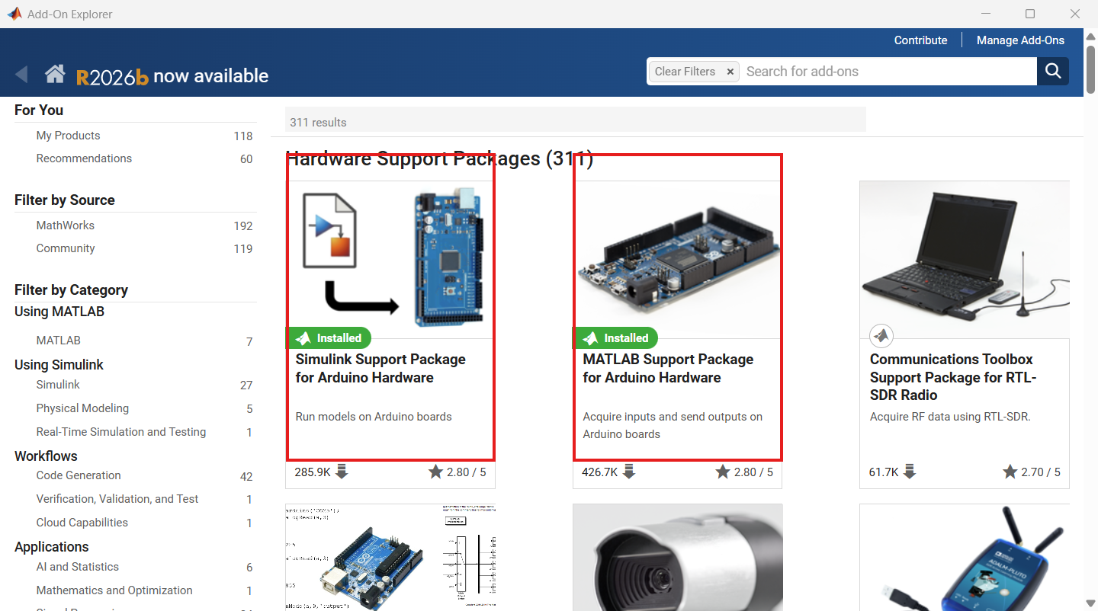
*Both Arduino packages are highlighted in red: Simulink Support Package for Arduino Hardware (left) and MATLAB Support Package for Arduino Hardware (middle). Both must show Installed.*
Minimum expected products (from `ver`):
--------- | --------------- | ---------
Stateflow | `ver('stateflow')` | State machine modelling
Simulink | `ver('simulink')` | Model host
Embedded Coder | `ver('embeddedcoder')` | Optimised, hardware-ready C

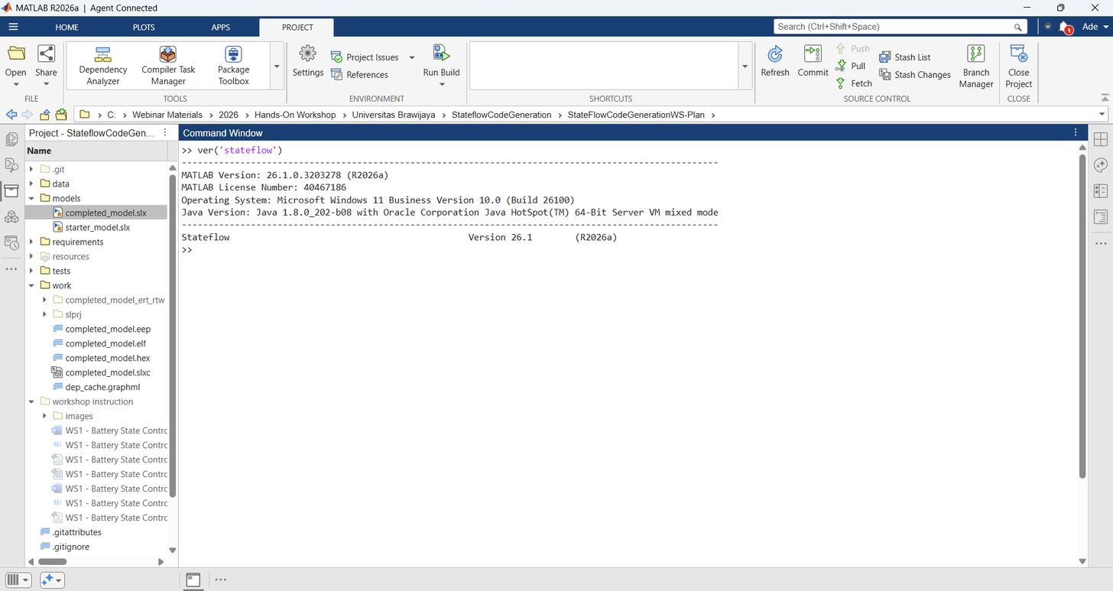
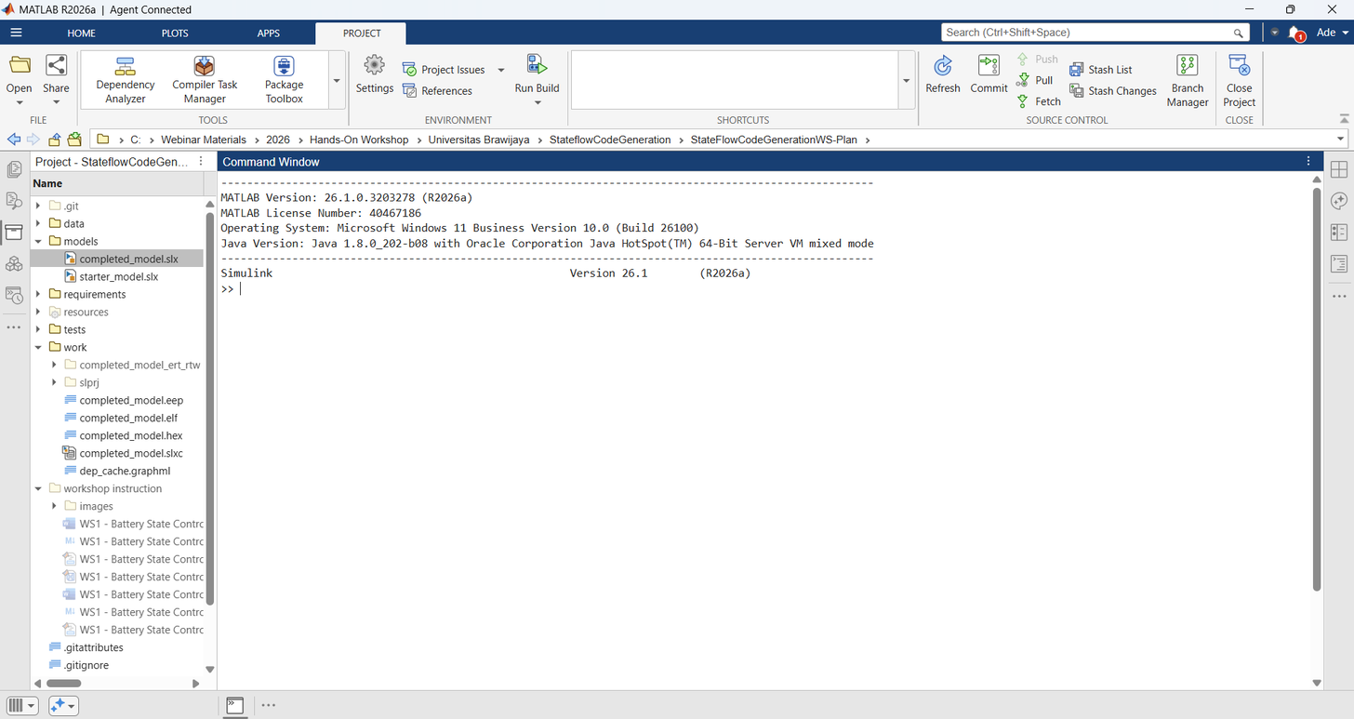
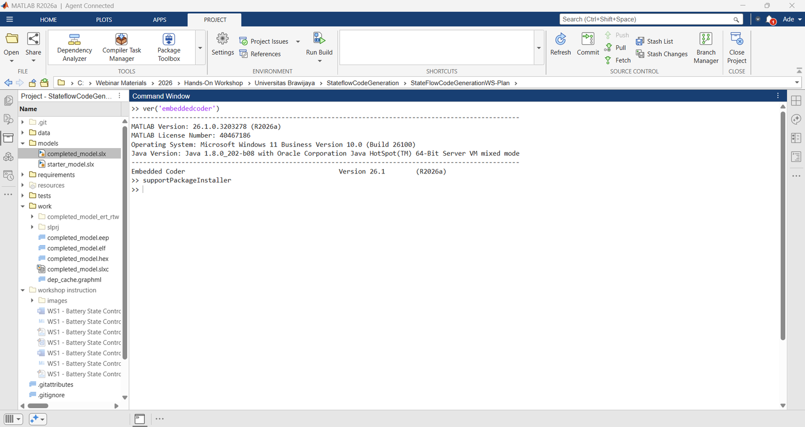
🔧 Installing a missing product (toolbox): open **Home → Add-Ons → Get Add-Ons** (Add-On Explorer), search the product name, and click **Install** (internet + MathWorks account required). The **Dependency Analyzer** (App → or `analyze` on your model or its dependencies) confirmed the required products for this workshop: **MATLAB, Simulink, Stateflow, Embedded Coder** — plus **Simulink Support Package for Arduino Hardware** for deployment.

4. Open the Starter Model (Step 2, ~5 min)
>> open_system('models/starter_model.slx')

The starter model already contains (read-only for this step):
- Dashboard Knobs — Voltage_Knob_V, Current_Knob_A, Temperature_Knob_C (simulation inputs).
- Source Select — Voltage_Source_Select, Current_Source_Select, Temperature_Source_Select (switch between simulation knobs and real Arduino pins).
- Input Scaling — converts knobs/ADC to Vpack, Ipack, BatteryTemp_C.
- Battery State Controller — the Stateflow chart. In the starter it is empty (no states yet).
- LED Output — drives led_idle, led_charging, led_discharging, state_id.
- Serial blocks — Serial_Packet_Mux + Arduino_Serial_Transmit (active only on hardware).
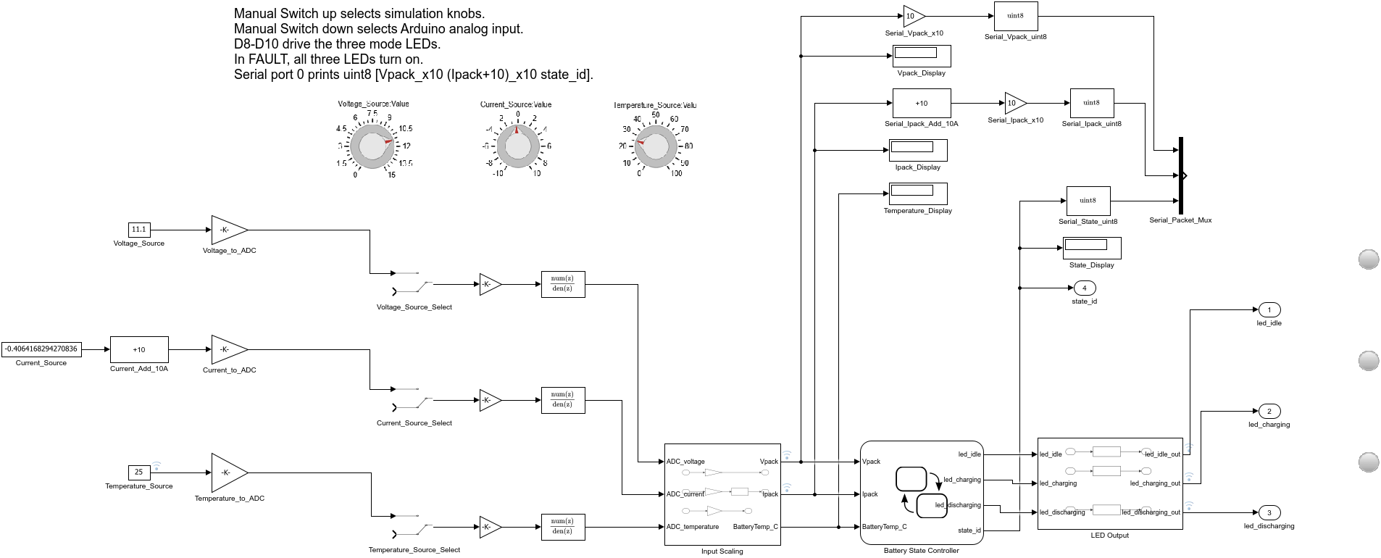
Figure 1: Top-level model as it opens in the starter — note the **Battery State Controller** chart block is still empty. Simulation inputs (Dashboard Knobs) feed Input Scaling, the chart will decide the state, and LEDs + Serial report it.
🎤 Narration (presenter): "The starter model is like a car without an engine. All the wiring — the dashboard, the scaling, the LED panel — is already connected. Your job in the next steps is to install the *brain*: the Stateflow chart that reads Vpack, Ipack, and BatteryTemp_C and decides which state we are in."

5. Build the Stateflow Chart (Steps 3–7, ~40 min)
Double-click the Battery State Controller chart to open the Stateflow Editor.

Step 3: Add the four states
Drag four State shapes from the Stateflow palette (or right-click → Add State) onto the canvas. Double-click each and name it:
------------ | ----------------------
`IDLE` | left, upper
`CHARGING` | center, upper
`DISCHARGING` | left, lower
`FAULT` | center, lower

Step 4: Add `during` actions to each state
Click inside each state and type its during action (runs every simulation step while in that state):
% IDLE
during:
led_idle = true; led_charging = false; led_discharging = false; state_id = uint8(0);

% CHARGING
during:
led_idle = false; led_charging = true; led_discharging = false; state_id = uint8(1);

% DISCHARGING
during:
led_idle = false; led_charging = false; led_discharging = true; state_id = uint8(2);

% FAULT
during:
led_idle = true; led_charging = true; led_discharging = true; state_id = uint8(3);

💡 Why `during`? The chart re-evaluates every step. A `during` action keeps the LEDs and `state_id` held correctly for the whole time the state is active — exactly what the requirements (REQ-06, REQ-07) ask for.

Step 5: Add the transitions (guards)
Draw a transition from one state to another, then double-click the arrow and type the guard condition inside [ ]. Build all transitions from requirements/battery_mode_requirements.csv:
----------- | ----------------- | -------------
IDLE → CHARGING | `[Ipack > 1.0 && Vpack >= 9.0 && Vpack <= 12.6]` | REQ-04
IDLE → DISCHARGING | `[Ipack < -1.0 && Vpack >= 9.0 && Vpack <= 12.6]` | REQ-05
IDLE → FAULT | *(see the block below)* | REQ-01/02/08
CHARGING → IDLE | `[Ipack <= 1.0 && Ipack >= -1.0]` | REQ-03
CHARGING → DISCHARGING | `[Ipack < -1.0 && Vpack >= 9.0 && Vpack <= 12.6]` | REQ-05
CHARGING → FAULT | *(see the block below)* | REQ-01/02/08
DISCHARGING → IDLE | `[Ipack <= 1.0 && Ipack >= -1.0]` | REQ-03
DISCHARGING → CHARGING | `[Ipack > 1.0 && Vpack >= 9.0 && Vpack <= 12.6]` | REQ-04
DISCHARGING → FAULT | *(see the block below)* | REQ-01/02/08
FAULT → IDLE | `[Vpack >= 9.0 && Vpack <= 12.6 && BatteryTemp_C <= 50 && Ipack >= -1.0 && Ipack <= 1.0]` | recovery

IDLE → FAULT [Vpack < 9.0 || Vpack > 12.6 || BatteryTemp_C > 50]
CHARGING → FAULT [Vpack < 9.0 || Vpack > 12.6 || BatteryTemp_C > 50]
DISCHARGING → FAULT [Vpack < 9.0 || Vpack > 12.6 || BatteryTemp_C > 50]

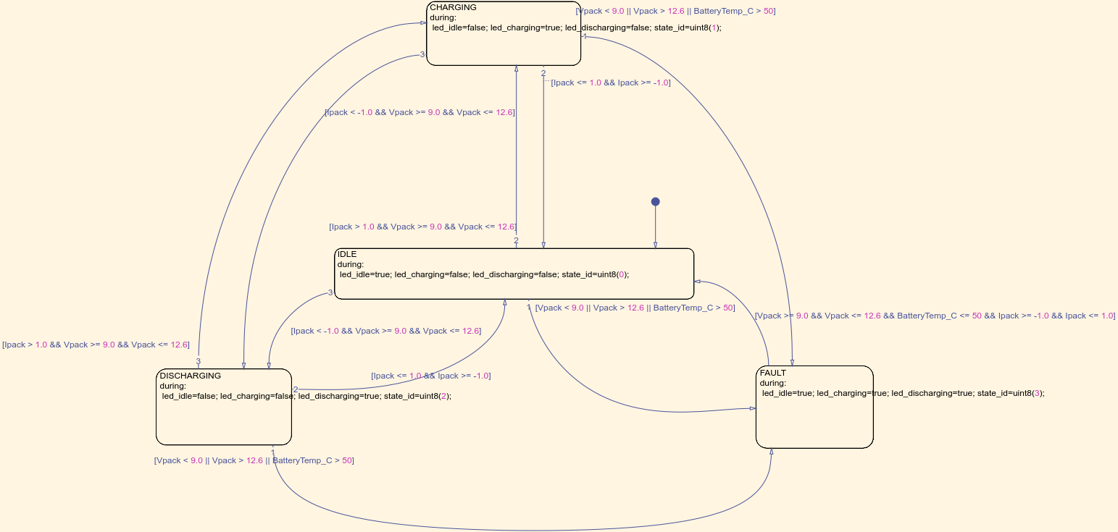
Figure 2: The completed 4-state chart with all transitions, as it appears in the Stateflow Editor. Use this as your reference while drawing.

Step 6: Confirm the chart data (inputs / outputs)
In the Stateflow Editor, open the Symbols pane (or Model Explorer). The chart must expose:
-------- | ------- | ------
`Vpack` | Input | double
`Ipack` | Input | double
`BatteryTemp_C` | Input | double
`led_idle` | Output | boolean
`led_charging` | Output | boolean
`led_discharging` | Output | boolean
`state_id` | Output | uint8

✅ If you named the states and actions exactly as above, Stateflow auto-resolves these symbols. If a symbol shows a red **?**, right-click it → **Resolve to Input/Output Data**.

Step 7: Update & save
>> set_param('starter_model','SimulationCommand','update')
>> save_system('starter_model')

6. Simulate & Validate (Step 8, ~15 min)
For desktop simulation, keep the Source Select switches up (toward the Dashboard knobs).

Step 8a: Run the 7 test cases
Open tests/battery_mode_test_cases.csv. For each row, set the three knobs to the Vpack, Ipack, Temperature_C values, then Run (Ctrl+T) and read state_id / the State Display.
--- | ----------- | ------- | ------- | ----------- | ---------------- | ----------
1 | Normal idle | 11.1 | 0 | 25 | IDLE | 0
2 | Charging | 11.1 | 5 | 25 | CHARGING | 1
3 | Discharging | 11.1 | -5 | 25 | DISCHARGING | 2
4 | Undervoltage fault | 8.5 | 0 | 25 | FAULT | 3
5 | Overvoltage fault | 13.0 | 0 | 25 | FAULT | 3
6 | Overtemperature fault | 11.1 | 0 | 60 | FAULT | 3
7 | Fault recovery | 11.1 | 0 | 25 | IDLE | 0

✅ Pass criterion: the State Display block shows the Expected State and `state_id` matches for all 7 cases. If a case fails, re-check the guard conditions (Step 5) — a typo in `&&` / `||` is the usual cause.
🪟 Tip: drag the knobs, then click **Run**. Watch `Vpack_Display`, `Ipack_Display`, `State_Display`. The expected value appears after one sample step (SampleTime 0.1 s).

7. Generate Code (Step 9, ~10 min)
With the logic validated, generate embedded C code:
>> slbuild('starter_model')

This runs Embedded Coder using the model's configuration:
- System target file: ert.tlc
- Hardware board: Arduino Uno
- Toolchain: Arduino AVR
Inspect the generated code (created in starter_model_ert_rtw/):
------ | ------------------
`starter_model.c` / `.h` | Model entry points (`model_initialize`, `model_step`, `model_terminate`)
`starter_model_data.c` | Parameters and signal data
`ert_main.c` | Example main loop (not used on Arduino — the support package provides its own)
`starter_model_generate_report.html` | Code generation report

💡 Key takeaway: the same Stateflow chart you drew produced a `model_step()` function that switches states in plain C — no manual coding. Open `starter_model.c` and search for `IDLE` / `CHARGING` to see how Stateflow compiles states into a `switch` on the state variable.
⚠️ An **Embedded Coder license** is required for `slbuild`. If you only have the Arduino Support Package, the *deploy* step (Step 10) still works because it triggers code generation internally — but the standalone `slbuild` report is the clearest way to *see* the code.

8. Deploy to Arduino Uno (Step 10, ~15 min)

Step 10a: Switch to hardware inputs
In the model, set the three Source Select switches down (toward the Arduino pins):
- Voltage_Source_Select → Arduino A0 (battery voltage divider)
- Current_Source_Select → Arduino A1 (current sensor)
- Temperature_Source_Select → Arduino A2 (temperature)
The LED Output block already maps to digital pins:
------- | ----- | -----
IDLE | D8 | led_idle
CHARGING | D9 | led_charging
DISCHARGING | D10 | led_discharging
FAULT | D8, D9, D10 | led_idle + led_charging + led_discharging (all ON)

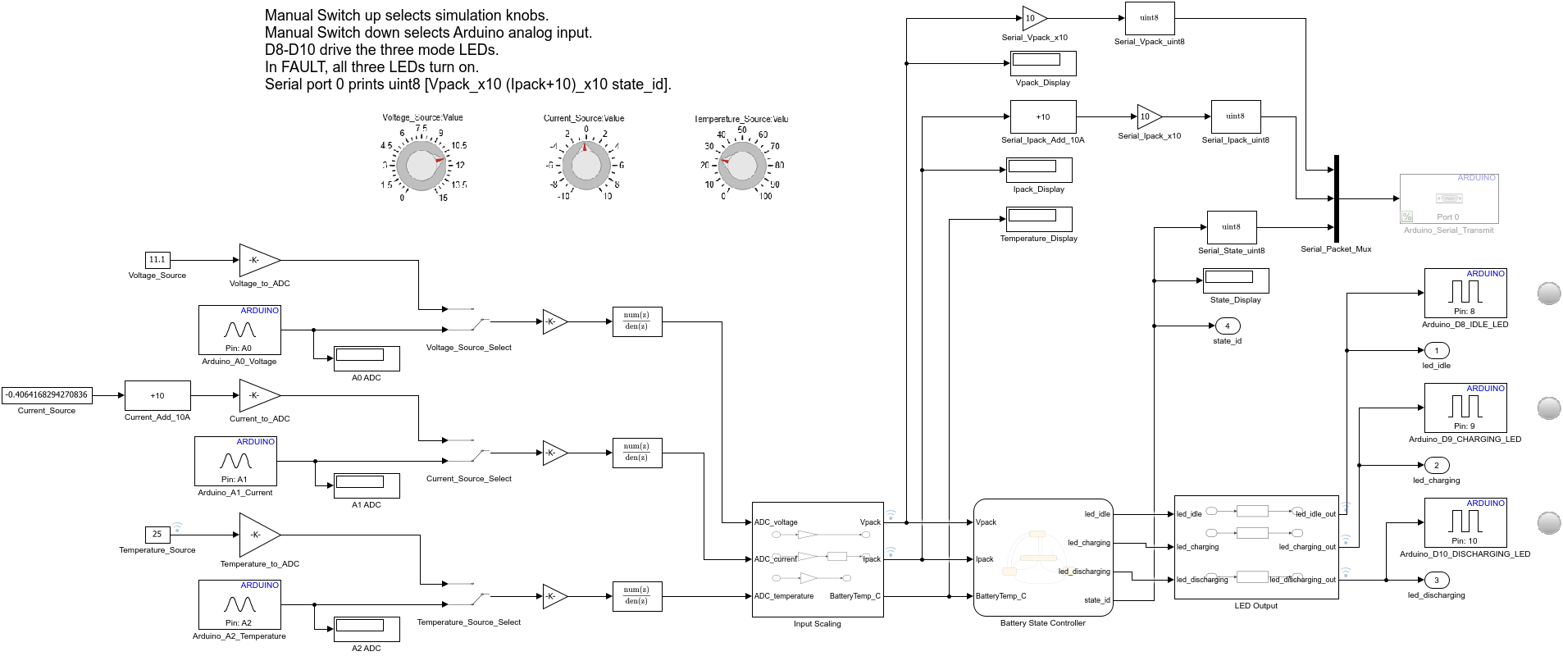
Figure 3: The completed top-level model ready for deployment — the Source Select switches feed the Arduino pins (A0/A1/A2), with the LED Output and Serial blocks wired.
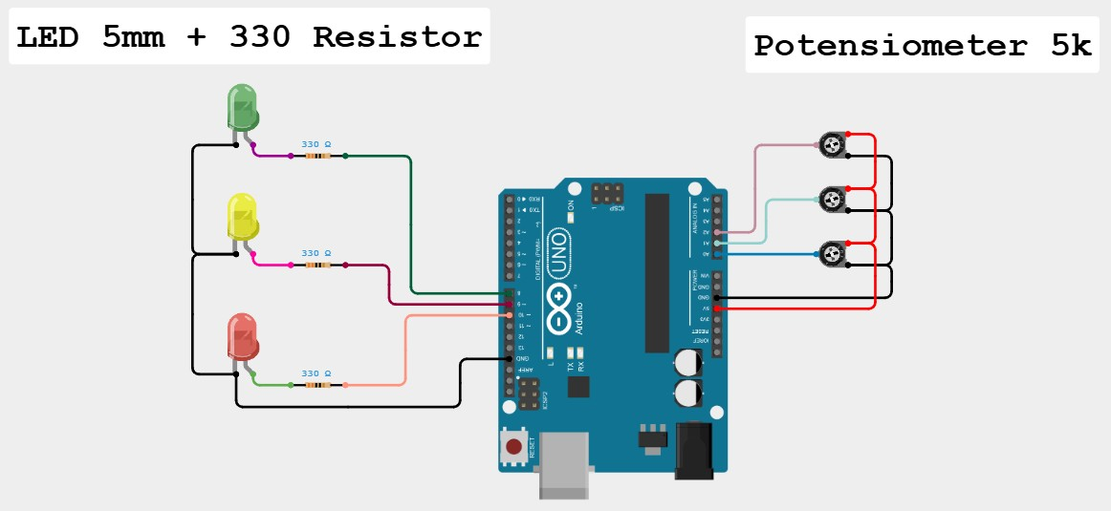
Figure 4: The fully assembled hardware — potentiometers on A0/A1/A2 and the three status LEDs (330 Ω) on D8/D9/D10.
🛠️ Wiring (per group): connect a **1 kΩ–20 kΩ** potentiometer to A0 (simulates Vpack), A1 (Ipack), A2 (temperature). Connect **3 LEDs** with 330 Ω resistors to **D8, D9, D10** (GND). For a quick check, sweep A0 with the pot: low voltage → FAULT (D8, D9, D10 all ON), safe mid → IDLE (D8 only), raise A1 above mid → CHARGING (D9 only), lower A1 below mid → DISCHARGING (D10 only).

Step 10b: Configure & build for hardware
1. Apps → Hardware Setup or set in Model Settings (Ctrl+E):
- Hardware Implementation → Hardware board: Arduino Uno
- Solver: Fixed-step, discrete (no continuous states), Fixed-step size 0.1
2. Hardware → Build, Deploy & Start (or Ctrl+B).
MATLAB compiles, uploads the .hex to the Uno over USB, and starts it.

Step 10c: Read the serial status packet
Open the Arduino Serial Monitor (or MATLAB serialport) at the default baud. The model transmits one byte packet per step:
[ Vpack_x10 , (Ipack+10)_x10 , state_id ]

Example: 111 100 0 → Vpack = 11.1 V, Ipack = 0.0 A, state = IDLE.
% Optional: read from MATLAB instead of the Serial Monitor
>> s = serialport("COM3", 9600); % replace COM3 with your port
>> read(s, 3, "uint8")

💡 Only one host may open the serial port at a time — close the Arduino Serial Monitor before using `serialport` in MATLAB, and vice versa.

9. Challenge (Step 11, ~10 min)
Change the undervoltage threshold from 9.0 to 9.6 V in every guard that references it:
- IDLE → FAULT, CHARGING → FAULT, DISCHARGING → FAULT: [Vpack < 9.6 || Vpack > 12.6 || BatteryTemp_C > 50]
- IDLE → CHARGING / DISCHARGING, and the recovery/charging guards: use Vpack >= 9.6 in the safe band.
Re-run test case 4 with Vpack = 9.3: previously IDLE (9.3 ≥ 9.0 = safe), now FAULT — the new guard [Vpack < 9.6 …] triggers, so the fault LEDs light at a higher voltage than before. Re-deploy to Arduino if time allows.
🔴 Advanced extension: add a 5th state `BALANCING` and a hysteresis band so the controller does not chatter between CHARGING and DISCHARGING when Ipack sits near 0 A.

10. Summary
------- | ------------------ | --------------
Verify | `ver('stateflow')`, `supportPackageInstaller` | Know what is installed before building
Model | Stateflow chart: states + `[guards]` + `during` | A state machine is just states + guarded transitions
Simulate | Dashboard knobs + 7 test cases | Validate logic *before* touching hardware
Generate | `slbuild('starter_model')` | Stateflow → readable embedded C
Deploy | Hardware board = Arduino Uno, `Ctrl+B` | Same model runs on real silicon
Observe | Serial packet `[V I state]` | Closed loop: model ↔ hardware

Architecture Learned
Requirements (CSV) -> Stateflow chart -> Simulink model -> Generated C -> Arduino Uno
REQ-01..08 4 states LEDs+Serial ert.tlc D8, D9, D10 + Serial

11. Troubleshooting
------- | ---------------- | ----------
Arduino support package missing | Not installed | `supportPackageInstaller` → install "Simulink Support Package for Arduino Hardware"
Symbol shows red `?` in chart | Scope not resolved | Right-click symbol → Resolve to Input/Output Data
Wrong state in simulation | Typo in an AND or OR guard | Compare guards to the Step 5 table line by line
`slbuild` license error | No coder license | Use Deploy (`Ctrl+B`) which generates internally; or obtain Embedded Coder
Upload fails / "port busy" | Serial Monitor open or wrong COM | Close Serial Monitor; pick correct COM port in Device Manager
LED never lights on Uno | Source Select still "up" | Flip the 3 Source Select switches **down** to Arduino pins
state_id wrong on hardware | Knob still driving input | Confirm Source Select = down (Arduino A0/A1/A2)

12. MathWorks References
- [Getting Started with Stateflow](https://www.mathworks.com/help/stateflow/getting-started-with-stateflow.html)
- [Model Finite State Machines](https://www.mathworks.com/help/stateflow/ug/why-use-stateflow-charts.html)
- [Generate Code for Arduino Hardware (Simulink)](https://www.mathworks.com/help/supportpkg/arduino/ug/install-support-for-arduino-hardware.html)
- [Simulink Support Package for Arduino Hardware](https://www.mathworks.com/hardware-support/arduino-simulink.html)
- [Getting Started with Embedded Coder](https://www.mathworks.com/help/ecoder/getting-started-with-embedded-coder.html)
*Hands-On Workshop material · TechSource Systems*

